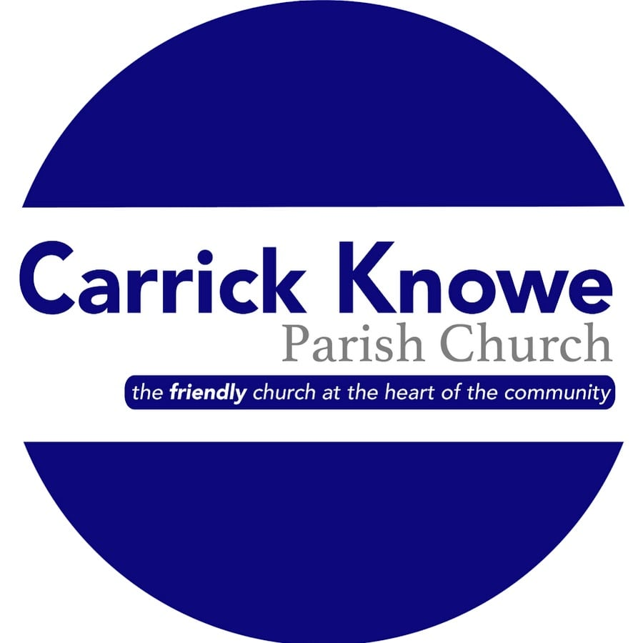
‘In it together’ Project

Children and Families Worker
Carrick Knowe is a busy parish church situated in the west of Edinburgh. The church buildings act as a focal point for the community, attracting more than 800 people through the week to a variety of church and community organisations.
We are looking for a Children and Families worker to take forward an existing project which over the past seven years has successfully delivered a range of events for families in our community such as ‘Meal and a Movie’ evenings, Cooking with Children classes, and craft afternoons. There is an established network of volunteers who are available and keen to support the work.
This appointment is for twelve months initially from a mutually agreed start date. The post is part-time, 10 hours per week, paid pro-rata based on an annual salary of £25,624. You will have an operational budget to pay for events and expenses.
We would expect you to work two hours on Sunday morning and two four hour sessions during the week (flexible and negotiable). You will report to the Minister as line manager and Chair Person of the Project, and to the Project Steering Group and Kirk Session.
Further information about the church and parish, and an application form for this job can be found on our website www.ckchurch.org.uk
You can also get more information from our Minister, Rev Fiona Mathieson 0131 334 9774, or 07895184022 fmathieson@churchofscotland.org.uk, or from our Joint Session Clerk, Finlay Buchanan 07742 965 432 finlay.buchanan@gmail.com
Completed application forms, along with a full C.V. and the names and addresses of two referees should be sent to the Minister at 21 Traquair Park West, Edinburgh EH12 7AN by Friday 16th April 2021. Interviews will be held on Tuesday 4th May 2021.

