L iberton Northfield Church
Parish Profile
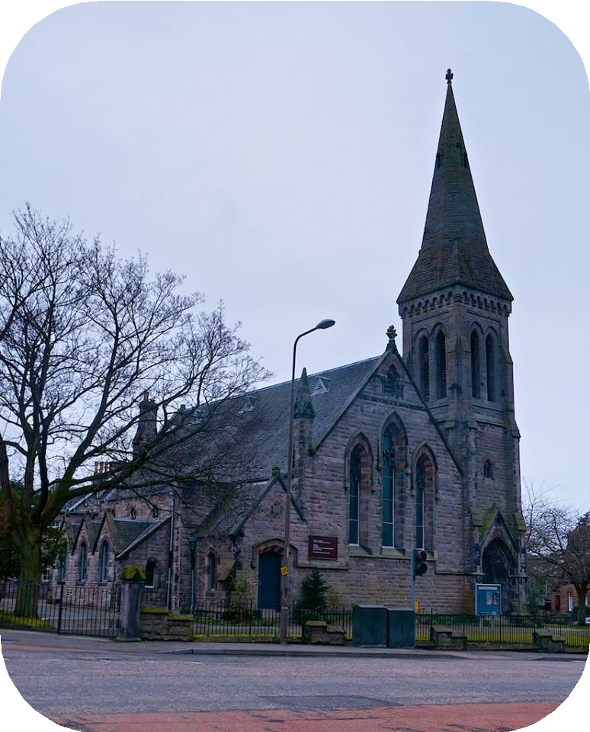

Contents:
- Introduction and Mission
- Our New Minister - A Brief Profile

What happens on Sundays
- What happens during the Week
- Our Community
- Our Leadership Team
- Our Finances and Buildings
- The City and our Area

1

Liberton Northfield Church Parish Profile
Introduction and Mission

‘To know Christ and to make him known.’
Welcome to our Parish Profile, and thanks for taking the time to read it. We hope you will find it helpful and informative and that it will enable you to discern whether or not you sense a call to serve here and participate in our mission to ‘To Know Christ and to make Him known’. We are asking all applicants to send us a CV together with a single page of A4 (12 pt font) in response to our profile. Tell us how you think your gifts link with our situation.

’

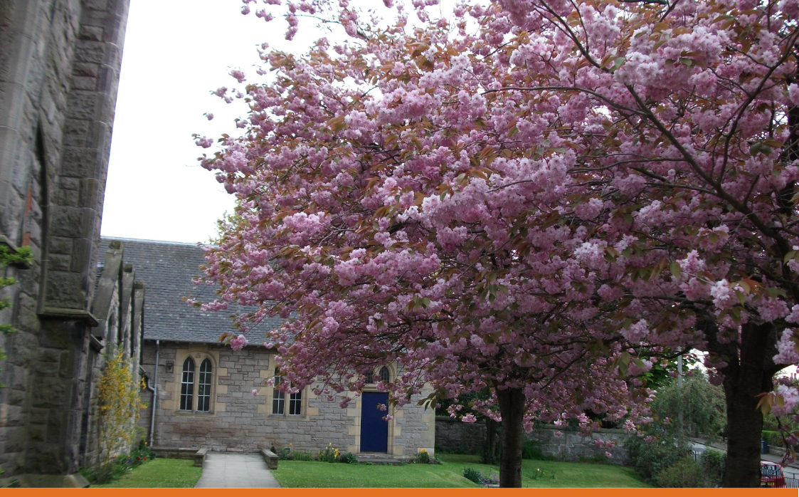

Our New Minister – a brief profile
We are seeking someone who will:

- nurture us in our faith with thoughtful biblical teaching, prayer, and a mix of both traditional and modern worship, tailored to the needs of the congregation.

- work alongside us as we seek to love one another and develop our skills, character, and leadership abilities as we share in congregational ministry

- have a heart for our community, and be willing to support and encourage us so that we can reach out appropriately to the diverse needs of our Children and Youth, Families, Friends, Neighbours, the Elderly, Parish, Workplaces, and beyond.

What happens on Sundays

Sunday Morning Service
The Sunday morning service is of a fairly traditional format, but in a welcoming style and includes modern as well as traditional hymns. Fischy Music songs, introduced a few years ago, are also used in local schools - and can be a good link between the work in schools with Sunday services. We have a rota of organists/ keyboard players who play on Sundays, and a small choir who help to lead the singing. Communion is normally celebrated four times per year.
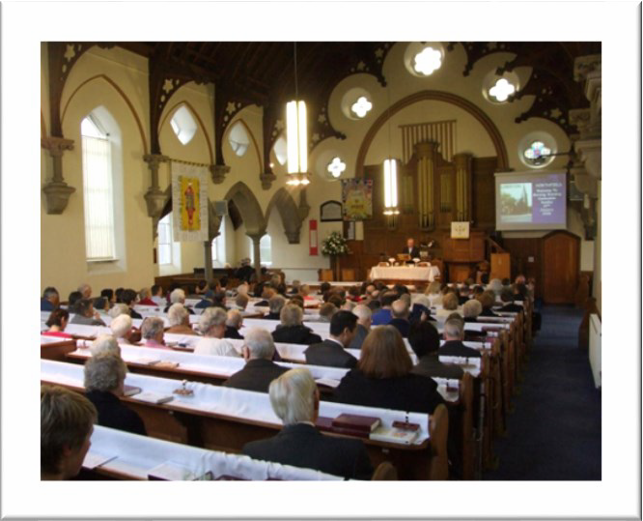
The children’s address and participation of the children at the beginning of the service is appreciated by the whole congregation. Members are happy to be involved in the readings and prayers of intercession.

We have data projectors and an up-to-date sound system with hearing loop. CDs of the Service are recorded for giving out to the housebound and others. Tea and coffee in the hall provides an opportunity for fellowship after the service. This along with welcoming duty at the doors and a flower ministry is provided by volunteers from the congregation.

Approximately 50 - 80 attend regularly on a Sunday morning (the current roll is 166 as at 31 December 2018). There is ramp access, a disabled toilet and baby changing facilities.

Trailblazers (Sunday School)

Currently we have approximately 15 children regularly attending church. Our Sunday children's activities are called Trailblazers. Trailblazers meets every Sunday during the morning service, after the children’s address. Activities include stories from the Bible with related games and crafts. Through the year we have a number of parties for the children and also events to include the whole church family. Children are awarded prizes for regular attendance and so children are encouraged as they see others receiving recognition. We aim to provide nurture and support to children and their families from birth, and have been very encouraged to see many new families joining us over the years. We run a Holiday Club each year, which in addition to attracting new families and children, encourages and equips more of the congregation to serve as leaders and helpers.

Evening Service

There is a weekly Evening Service that is smaller (approximately 5 - 12 members) and more informal with differing formats for example, open prayer, testimonies and litergy. During the vacancy this is being organised by one of our Elders, and led most weeks by a rota of members of the congregation. We occasionally have joint evening services with the other churches in the Parish grouping. Over the summer months we use our Evening Service slot for outreach in the Parish. Last Summer we visited around 100 homes in the parish and distributed leaflets to around 600 more, providing information about the activities going on at the church and inviting people to a community barbecue and praise event in late August which was attended by around 25 people who had no previous connection with the church.

Other Services

The church holds a monthly service at Tressilian Gardens, a sheltered housing complex within the parish, with between 6 – 12 individuals attending. Members are also involved with SEECAT monthly services at Liberton Hospital. Worship extends beyond Sundays and includes times of prayer, Bible Study and fellowship.

What happens during the week

Children, Families and Youth Work

Under the ministry of Bill Thompson in the 1990s there was a focus on prayer, especially for the local schools, which at that point denied access to chaplaincy teams. Encouraged by Bill Thompson, the local ministers in the Parish Grouping joined regularly to pray for the South-East of Edinburgh, and in support of each other. This link has strengthened over the years and continues to the current time. Following the retirement of Bill Thompson in 1999, John McPake took over as minister in 2000. By then permission for providing chaplaincy services had been gained within the schools in the area. During the period from 2000 to 2013 there was (and continues to be) encouraging work with very young children and their families (New Life Tots, and Mums and Tots Group), and joint outreach activity with other churches in the south- east of Edinburgh ("The Big Idea"). During the vacancy following John McPake's retirement, we developed our work with primary school-aged pupils with holiday clubs in conjunction with SU Scotland. These have continued annually and last year we had 52 children attending. More recently we have developed our outreach to Liberton High School through "Toastie Tuesday" which provides lunch to an average of 170 pupils each Tuesday during term time, and other initiatives working with Young Life International. We have plans to develop this work further by hosting a Youth worker in conjunction with Young Life International who will be based part time at Liberton Northfield.

Brownies and Rainbows began two years ago. There are 10 Rainbows and 20 Brownies. We hope to develop closer links in future with them.

Prayer and Bible Studies

A Prayer Group meets on Saturday mornings. A time for prayer is also set aside after the end of the morning service for anyone who would like prayer for particular issues. In conjunction with the other churches in our parish grouping we run 24 hour prayer events, and have supported the Try Praying initiative. We are also involved in SEECAT Week of Prayer for Christian Unity, and World Day of Prayer. We want to develop prayer in the life of the congregation.

We have two midweek Bible studies that meet in the church and in a member’s home and also run Alpha/ Christianity Explored courses. In addition, we have the Fellowship (was the Guild), and a recently re-vitalised Men's Group.

Other Activites

- A team visit the elderly and housebound. They sometimes transport people to the Tresilian Sunday service.
- The flowers ministry distributes flowers weekly to people within the congregation and parish as expressions of care and support.
- The minister’s discretionary benevolent fund is used to assist those in need in the congregation and parish.
- Claverhouse Conversations is an occasional event at which invited guests speak about their life, work and faith. These events begin with breakfast and are open to the parish.
- Liberton Northfield works with other local Church of Scotland congregations and churches from other denominations in a range of Christian outreach projects, eg The Big Idea, Messy in the Park, SEECAT and the Parish Grouping.
- Work with Bethany Christian Trust Night Shelter.
- We continue to be blessed by having individuals and families from many different backgrounds, nations and cultures as part of the congregation.

Our Community

The Parish
In the 2011 census, the parish population was 6355 people living in approximately 3,000 houses. The population structure is not dissimilar to the pattern for the city but with slightly more children (0 to 15 years) and more in the mature and elderly (45 years +) age groups.

Liberton Primary, St John Vianney RC Primary and Liberton High Schools, are located within the parish. Tressilian Gardens Sheltered Housing Complex, the Inchview Care Home and the Inch House Community Centre are also located within the parish.

The University of Edinburgh’s King’s Buildings campus is close to the parish, and there is new student accommodation within the parish.

The Cameron Toll Shopping Centre is adjacent to the parish, and due to the close proximity of the New Royal Infirmary, a number of frequent buses serve the area and a bus journey into the city centre takes around 20 minutes.

Full information on the parish can be found in the appended church of Scotland Statistics for Mission document here
https://cos.churchofscotland.org.uk/church_finder/profile.php?property_id=17314

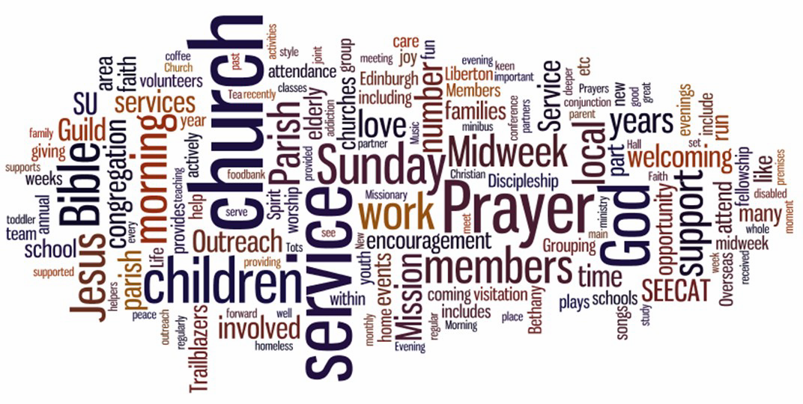
©HarperColins Publishers 2006 ©Crown Copyright Reserved

Finances

Our most recent figures are:

 | 2016 | 2017 | 2018
Income | £62,695 | £71,434 | £52,931
Expenditure | £61,188 | £57,304 | £61,012

Our congregational contribution to the Presbytery Ministry and Mission Fund was paid in full. The Kirk Session will be considering how to address issues of stewardship within our church.

The Buildings

The Church
The church consists of the main church building, a large hall, a small ground floor meeting room, kitchen, an upstairs meeting room and vestry and a large entrance area.

A garage within church grounds is currently used for storage of church equipment. No major repairs are outstanding and the five-year inspection in August 2017 was very favourable.

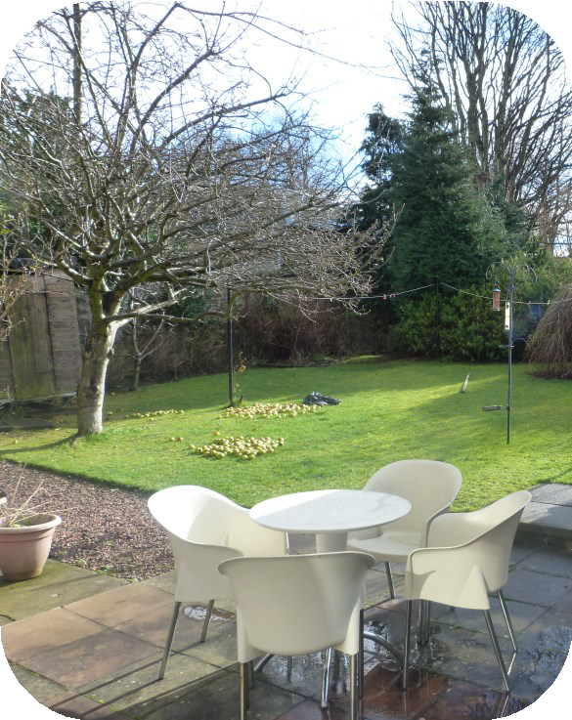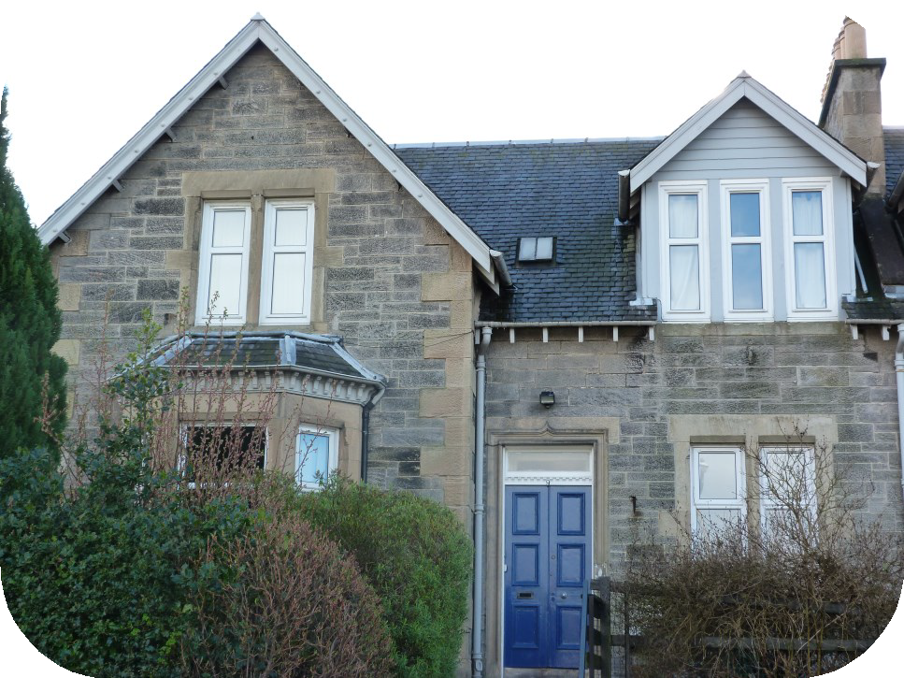

The Manse
9 Claverhouse Drive, Edinburgh, EH16 6DR
(Title Deeds held with the General Trustees)
- Ground floor consists of a large entrance hall with feature stair-case, lounge, study, dining room, small toilet, and kitchen.
- 1st floor; 3 double bedrooms, 1 single bedroom, and a bathroom.
- Front garden with off-street parking, large back garden with 2 wooden sheds.
- No major repairs are outstanding
- Lounge redecorated and bathroom refurbished recently
- Kitchen modernisation underway.

About the City and Our Area

Our local area
It is a 20 minute bus journey into the Edinburgh city centre but is within easy reach of parkland, seaside and hill country.
Both Liberton Primary School and Liberton High School are a short walk from the manse.

The Parish

The parish of Liberton Northfield lies to the south-east of the city and is approximately 1 mile by 1.5 miles in area. It is bounded on three sides by parkland and is close to the Edinburgh City Bypass. The Inch housing estate, built by the Council in the early 1950’s post-war years, is the main and largest housing area in the parish. The most recent housing additions have been a number of smaller private estates. Right-to-buy has altered the pattern of housing tenure in the parish and by 2008 two-thirds of the houses were owner-occupied with the majority of houses being flats and terraced villas.

Contact Us

Applications should be sent to the Clerk to the Nominating Committee – Mr Ian Aitken, 8/1 Nether Liberton Court, Edinburgh, EH16 5UN, email:johnwaitken59@yahoo.com tel 07445 016116.

