Fairmilehead Parish Church
Edinburgh
The Church of Scotland
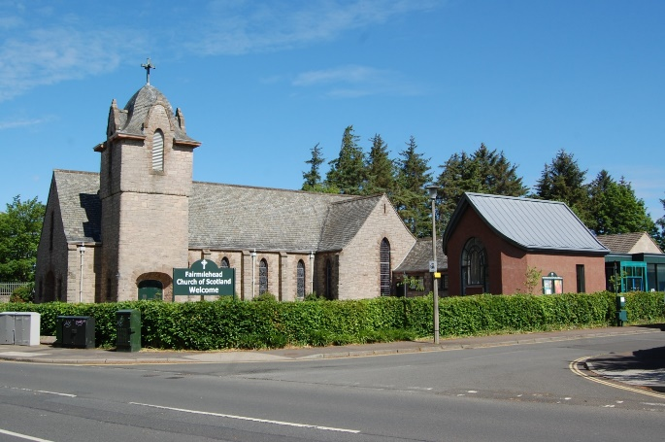
Job Description

Title of Post: Parish Assistant - Fairmilehead Parish Church, Edinburgh

Responsible to: The Minister and Kirk Session of Fairmilehead Parish Church

Date: January 2020

Main purpose of post: To work intergenerationally within the Parish, supporting the Minister both in worship and pastoral care, and extending outreach.

Main Duties:

- To provide pastoral care intergenerationally and work with the Spiritual Planning and Bereavement Team.
- Initiate and take a midweek worship service. Training can be provided.
- To initiate at least one midweek activity to combat isolation and loneliness.
- To assist at the Youth Voice Project.
- Lead aspects of Sunday worship when required.
- To conduct Parish funerals and provide post funeral care. Funeral training can be provided.
- To identify, recruit and train potential volunteers to assist with the work.
- To cover pastorally for the Minister during her holidays. This cover may also include leading aspects of Sunday Worship.
Additional Duties:

- Assist and coordinate the new Worship Team who support Sunday services.
- Be involved with our Teenage Group on occasional Sundays.
- Attendance at additional afternoon and evening services may be required during Holy Week and Christmas.
- To engage with hall users in agreement with the Minister.
- To meet regularly with the Minister.
- Provide twice yearly written reports to Kirk Session.

Person Specification: Parish Assistant

Skills, abilities and knowledge | Essential | Desirable
Experience in working with people of all ages | X
Ability to engage and relate to those who have little or no church connection | X
Experience in worship and bereavement training and conducting of funerals |  | X
Experience of Messy Church |  | X
Ability to prioritise workload. | X
Experience of working with, motivating and training volunteers. |  | X
Holder of full valid driving licence. |  | X
Personal Qualities
Committed Christian with a live Church connection which is a Genuine Occupational Requirement in terms of the Equality Act 2010 | X
Highly developed interpersonal skills and ability to communicate effectively with others. | X
Highly motivated with ability to work unsupervised and a readiness to use own initiative. | X
Ability to share your faith journey with those you encounter in a sensitive and appropriate manner. | X
Proven ability to work collaboratively with colleagues and volunteers and contribute to effective team working. | X
Educational Requirements
Qualified to degree level or similar, or accredited training. | X

Additional information:

Normal working pattern: 27 hours per week, worked over five days. Days off Tuesday and Saturday. Sundays 10am -12 pm. Monday 10am - 4pm & 6.30pm to 9pm. Wednesday 10am - 6.30 pm. Thursday 11.30am - 4pm
Friday 11am - 5pm. These hours include an unpaid lunch break of 30 minutes.

Salary: £16,700 - £18,083 per annum

Holiday entitlement: 28 days (including public holidays). Of which 14 days to be taken during school holidays.

- Appointment will be subject to a satisfactory enhanced disclosure and PVG from Disclosure Scotland.
- Appointment will be subject to satisfactory references.
- Appointment will be subject to the satisfactory completion of a 3-month probationary period.

The Parish Minister will not be the line manager.

Travel expenses: Pastoral Mileage will be paid at 25p per mile.

This post is a fixed contract for two years based at the Church Centre. Office space and access to a computer will be provided.

Application Process

There is no application form. Applications should take the form of a letter clearly and specifically outlining how the applicant’s skills and experience relate to the requirements of the job description and should include a CV.

Applications should be addressed to Rev Cheryl McKellar Young, either:-

by post to: Rev Cheryl McKellar Young Fairmilehead Parish Church, 1A Frogston Road West,
Edinburgh EH10 7AA

or by email to: CMcKellarYoung@churchofscotland.org.uk

The closing date for applications is 10 February 2020

Fairmilehead Parish Church, 1a Frogston Road West, Edinburgh EH10 7AA. SC015967

